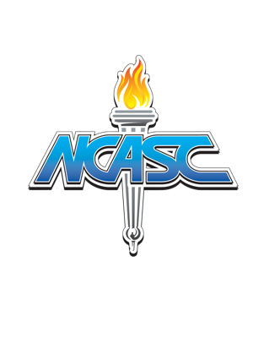
North Carolina Association of Student Councils, Inc.
Executive Board
2024-2025

President School | Piedmont HS | Dylan Tepera  Annette Harris  Britney Forbis  Katie Haigler | Student Representative  Advisor  Advisor  Advisor
President-Elect School | Central Academy of Arts  and Technology HS | Emerson Villanueva  Thomas Stewart  Sally Goodwin | Student Representative Advisor  Advisor
First Vice President School | Sun Valley HS | Don Leimkuhler  Jennifer Goodson | Student Representative Advisor
Second Vice President School | Gray’s Creek MS | Alarya Kennedy  Karin Ghent | Student Representative Advisor
Secretary School | Forest Hills HS | Walker Dockery Christi Ponder | Student Representative Advisor
Communications Officer School | Marvin Ridge MS | Akshara Dasika  Lisa Hansen | Student Representative Advisor
Eastern District Chair | Rocky Mount HS | Ahnaya Bellamy  Kenneth Jones | Student Representative Advisor
Eastern District HS Vice Chair | Roanoke Rapids HS | Elisabeth Love  Gary Edwards | Student Representative Advisor
Eastern District MS Vice Chair |  |  | Student Representative Advisor
Central District Chair | Southern Alamance HS | Emma Smith  Teri Rasa | Student Representative Advisor
Central District HS Vice Chair | Cumberland Polytech HS | Kaianna McKethan  Carla McKethan  Cynthia Rios | Student Representative Advisor  Advisor
Central District MS Vice Chair | Wakefield MS | Rylee Davis  Gina DeBose  Christina Levey | Student Representative Advisor  Advisor
Western District Chair | Sun Valley HS | Isabella Ocejo  Jennifer Goodson | Student Representative Advisor
Western District HS Vice Chair | R-S Central HS | Savannah Hodge  Tami Myslinski | Student Representative Advisor
Western District MS Vice Chair | Marvin Ridge MS | Ishan Bhimani  Lisa Hansen | Student Representative Advisor
Board of Directors | Forest Hills HS | Bryan Rudolph | Executive Director
Board of Directors |  |  | Assistant Executive Director
Board of Directors | NCASC | John McLeod | Eastern District Director
Board of Directors | Leesville Road HS | Keysha Mayfield | Central District Director
Board of Directors | Porter Ridge HS | Josh Wall | Western District Director
Board of Directors | North Surry HS | Daron Atkins | Membership Director*
Board of Directors NCASC Henry Foust Outreach Director*

34 Members; 2 Ex-Officio Members* (Unduplicated) March 23, 2024

